**Collective downloading**

**Aras Innovator Community Projects**

**Description**

**What is “collective downloading”**

* We provide the function that allows to download batch of files associated with Item Type of Aras Innovator.
* As Item Type relation it is limited with case if File Item Type is set.

1. Target item type file information list display function (it is possible to load multiple relations)
2. Function that allows to change batch downloading destination (working directory)
3. Function that allows to download batch of chosen files (with overlapping confirmation)

* There is no possibility to change a download destination (working folder) with known problems of ArasInnovator11sp6 in Chrome.

**Deploy documentation**

1. Copy folders below a Client folder to Aras Innovator folders below a Client folder.
2. Import packages below a Package folder into Aras Innovator. To import, please, use Aras Innovator utility tool.
3. We provide Japanese language support using LanguagePackManagementUtility.
4. Set action [z_manageALLDLFile] to action of the files you want to download if necessary.

**Folder layout**

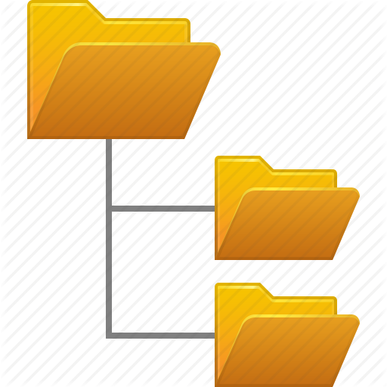

Installation destination/Innovator

Solution

Client

**Screen image**

**Action settings**

Add action to the target item types that you want to download as a batch.

Screen shows the example of setting the action [z_manageALLDLFile] to Document Item Type.

**Invoking of the screen for batch downloading**

Execute “target item types files batch download” from Action

It is possible to call action from both item type details and search grid.

When you execute “target item types files batch download” the screen for batch downloading will be shown in modal window.

**Screen for batch downloading**

List of the files that can be downloaded is shown

Refresh function

View file item function

Batch downloading start button

Select all function (word for word translation: “select Grid inverting function”)

Yellow sections mean the files are chosen for downloading

View file item by double clicking

Change downloading destination (working directory) function

**Batch downloading**

The files selected for working directory (downloading destination), are downloaded automatically.

The result of the downloading is shown on the top of the screen.

**In case of overlapping**

A confirmation dialog appears when downloading destination (working directory) contains duplicate files. Select either draft or cancel the dialog.

Be aware that it is impossible to save the file with different name.

A confirmation dialog appears every time downloading destination contains duplicate files.

**Another example**

When batch downloading action is set to “ECO”

In general, it is possible to use batch downloading function just by setting an action.

**Another example 2**

When there are multiple File relations

It is possible to skip multiple relations and download a batch.

**Release version**

* Correspond to 2.00 Ver11SP6 (May 18, 2016)

**Additional future functions:**

Downloading files compression function

Function which allows to get list automatically (with setting special rule) for Files Item Type of nest structure

Deal with File tem type in CAD document